ECEN 350 – Equation Sheet 2 (12/27/2024)
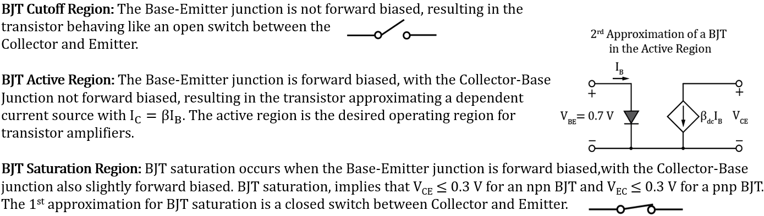

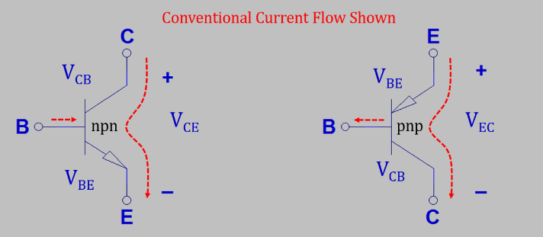
$For a BJT in the active region:$

$α ≜ {I_{C}}/{I_{E}}.$ $\text{β}≜{I_{C}}/{I_{B}}.$
$$I_{C}=βI_{B}. I_{E}= I_{C}+I_{B}≈I_{C}.$$

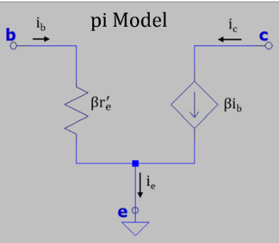
Good coupling: X_{C} < 0.1R, where R is the equivalent input or output resistance, with $X_{C}=1/{2πfC}.$
Good bypassing: X_{C} < 0.1R, where R is the equivalent resistance of the parallel element to short out for ac signals.
$$Small-Signal Analysis: i_{c}=βi_{b}, i_{e}=βi_{b}, r_{e}^{'}=\frac{25 mV}{I_{E}}.$$
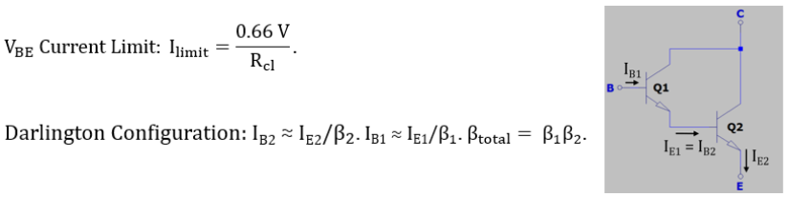
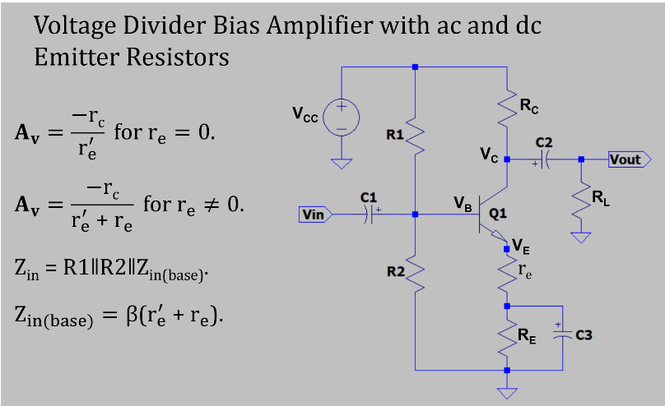
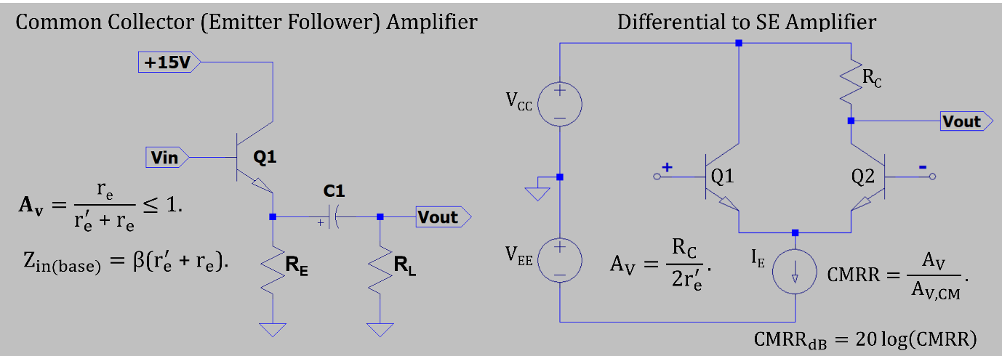
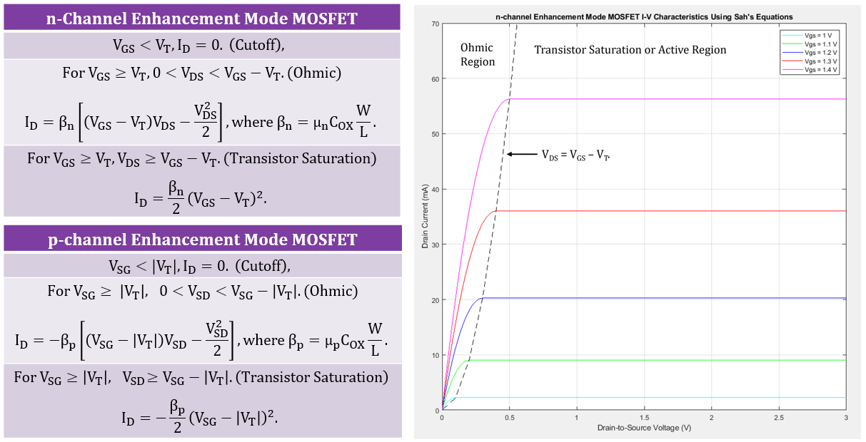
CMOS Dynamic Power Dissipation: $P_{Dynamic}=C_{Load}N_{SW}V_{DD}^{2}f, where V_{DD} is the supply$
Voltage, N_{SW} is the number of nodes switching and f is the switching frequency.
$$Sizing CMOS Digital Logic: W_{p}=\frac{μ_{n}}{μ_{p}}W_{n}, where μ is mobility, W_{n} is the relative width of$$
the n-channel transistor and W_{p} is the relative width of the p-channel transistor.

